

|  |  |
| --- | --- |
| **CourseTitle**:Machine Learning | CourseCode:BCSE209L |
| **Faculty**:Prof. R. Jothi | **Slot:** G1+TG1 |
| **Regno:***21BCE5909,21BCE5937,*  *21BCE6022* | **Name:**Dev Bhasin,Arin Yadav,  Shreyash Verma |
| **Program:**BCE(CSE CORE) | **Batch Year:**THIRD |

**Project Review – 3**

**Project Name:** Sales Prediction

**ABSTRACT:**

In the current digital age, the sheer volume of theoretical data generated is staggering, surpassing the capacity of any single individual to process. As a consequence, there has been an explosion of machine learning methodologies aimed at leveraging this vast wealth of information. Our primary objective is to forecast sales across various stores by exploring and comparing different machine learning techniques. Through experimentation with both conventional regression methodologies and advanced boosting algorithms, we seek to ascertain whether boosting techniques exhibit superior predictive performance compared to traditional regression approaches.

Efficient sales prediction analysis demands the utilization of intelligent data mining methodologies that leverage precise prediction models to generate highly reliable outcomes. A deep understanding and expertise across diverse market segments play a pivotal role in this endeavor. Particularly challenging is the task of forecasting demand for business-to-business sales data analysis, where the sheer magnitude of big data and the nuanced intricacies of sales forecasting pose significant challenges for traditional forecasting systems. In this study, our focus lies on analyzing the predictability of sales using state-of-the-art machine learning techniques.

The outcomes of this research endeavor are expected to yield accurate, precise, and actionable forecasting data, which will serve as a valuable resource for making informed predictions about future sales trends. By harnessing the power of advanced machine learning algorithms, we aim to provide decision-makers with invaluable insights that can drive strategic business decisions and enhance overall operational efficiency.

**PROBLEM STATEMENT:**

The problem statement in a research paper articulates the specific issue or challenge that the study aims to address. It provides a clear understanding of the problem domain, highlighting the gap or deficiency in existing knowledge or practice that the research seeks to fill. Here's an in-depth explanation of the problem statement provided:

In the realm of contemporary business operations, the ability to accurately predict sales turnovers is paramount for organizational success. However, amidst the ever-growing volumes of data generated by businesses, traditional methods of sales prediction often prove inadequate. These methods lack the agility and precision required to analyze vast datasets efficiently and make timely, informed decisions. As a result, businesses are confronted with the challenge of developing intelligent sales prediction systems capable of processing data swiftly and accurately.

The primary issue lies in the inefficiency of existing approaches to sales prediction, which rely heavily on manual analysis or simplistic statistical models. These approaches are ill-equipped to handle the complexities inherent in modern business environments, such as fluctuating consumer behaviors, dynamic market trends, and diverse product portfolios. Consequently, organizations face significant obstacles in accurately forecasting sales turnovers and optimizing business strategies accordingly.

Furthermore, the proliferation of data sources and the sheer volume of data available pose additional challenges. Managing and analyzing large datasets require robust methodologies and scalable solutions. However, many organizations struggle to leverage these datasets effectively, often encountering difficulties in data preprocessing, feature selection, and model interpretation.

In light of these challenges, there is a pressing need for innovative approaches to sales prediction that harness the power of machine learning and data analytics. By leveraging advanced algorithms and techniques, such as predictive modeling, pattern recognition, and data mining, organizations can unlock valuable insights hidden within their data. These insights can inform strategic decision-making processes, enabling businesses to anticipate market trends, identify lucrative opportunities, and optimize resource allocation.

Thus, the overarching problem addressed in this research is the inadequacy of current methods for sales prediction in meeting the demands of modern business environments. By developing and implementing intelligent sales prediction systems grounded in machine learning and data analytics, organizations can enhance their competitiveness, drive revenue growth, and navigate the complexities of today's marketplace with confidence.

**INTRODUCTION:**

One of the primary aims of our research initiative is to establish a robust mechanism for reliably predicting sales trends. In today's business landscape, organizations are confronted with an ever-expanding reservoir of data, with projections indicating a continued exponential growth trajectory. It is imperative for businesses to implement measures that can accommodate the rapid pace of transaction processing and effectively manage the anticipated surge in data volume, as well as evolving customer behaviors.

Accurate sales predictions serve as a linchpin for driving market growth and maximizing revenue generation. They furnish organizations with invaluable insights that inform critical decision-making processes across various functional domains, including operations, marketing, sales, production, and finance. By leveraging predictive sales data, businesses are equipped to optimize resource allocation, enhance operational efficiency, and capitalize on emerging market opportunities. Moreover, these forecasts play a pivotal role in attracting investment capital, as they provide prospective investors with a comprehensive understanding of the organization's growth potential and market positioning.

Our research endeavors to introduce a fresh perspective by exploring methodologies that offer a high degree of precision in sales forecasting. Central to this pursuit is the identification and adoption of approaches that can effectively capture the complex interplay of factors influencing sales dynamics. By delving into the nuances of different forecasting techniques, we aim to equip organizations with the tools and insights needed to navigate the intricacies of today's competitive marketplace with confidence and foresight.

**LITERATURE REVIEW:**

**1. Sales forecasting using machine learning algorithms**

<https://www.researchgate.net/publication/372534840_Sales_forecasting_using_machine_learning_algorithms>

The objective of this research paper is to provide a comprehensive analysis of time series analysis and forecasting techniques. We delve into the principles underlying these methods, their practical applications, and their performance across a range of scenarios. Through empirical experiments and case studies, we rigorously evaluate the effectiveness of various approaches, shedding light on their strengths, limitations, and potential pitfalls. By comparing and contrasting their performance on multiple datasets, we aim to offer insights that guide practitioners in selecting the most appropriate technique for a given context.

**2. An Analysis of Time Series Analysis and Forecasting Techniques** <https://www.researchgate.net/publication/375238697_An_Analysis_of_Time_Series_Analysis_and_Forecasting_Techniques>

The research paper aims to conduct an in-depth analysis of time series analysis and forecasting techniques. It explores the fundamental principles, practical applications, and performance of these methods across diverse scenarios. Through empirical experiments and case studies, the paper rigorously evaluates the effectiveness of various approaches, highlighting their strengths, limitations, and potential pitfalls. By comparing and contrasting their performance on multiple datasets, the goal is to provide insights that assist practitioners in selecting the most suitable technique for specific contexts.

**3. SALES FORECASTING USING MACHINE LEARNING TECHNIQUES BY Garud Akshada Anil*1, Chavan Ritambara Shankar*2, Bobade Prachi Santosh*3, Gorad Akshada Rajendra*4, Prof. B.D. Thorat*5**

[<https://www.irjmets.com/uploadedfiles/paper/issue_3_march_2023/34569/final/fin_irjmets1679321607.pdf>](https://www.irjmets.com/uploadedfiles/paper/issue_3_march_2023/34569/final/fin_irjmets1679321607.pdf)

The paper investigates the application of machine learning techniques for sales forecasting, aiming to create precise models that anticipate future sales based on past data. Various machine learning algorithms, including neural networks, decision trees, and regression, are compared to determine the most effective approach for predicting sales. The study emphasizes the importance of advanced analytical methods for sales management and forecasting, covering aspects such as data preparation, feature engineering, model selection, evaluation, and optimization. The methodology involves phases such as data collection, preprocessing, feature engineering, model selection, training, evaluation, optimization, forecasting, and model maintenance, highlighting the iterative nature of the process to achieve accurate results.

4. **Forecasting of a Fashion Retailer's Sales using Machine Learning through COVID-19**

<https://www.researchgate.net/publication/372335607_Forecasting_of_a_Fashion_Retailer's_Sales_using_Machine_Learning_through_COVID-19>

The study focuses on utilizing machine learning techniques to forecast sales for a Brazilian fashion retailer before, during, and after the COVID-19 pandemic. With the retail industry being significantly impacted by the pandemic, accurate sales forecasting becomes crucial for informed decision-making. The research tests SARIMA and NNAR models and finds NNAR to be more effective, especially during normal and promotional sales periods. Sales variability increases before and after restrictions, particularly during discount periods, with higher prediction errors. However, promotional efforts during lockdowns exhibit a lower impact on customer behavior, leading to more stable sales. The study highlights the importance of accurate sales predictions in navigating the challenges posed by COVID-19 in the retail sector.

5. **Comparative Analysis of Supervised Machine Learning Techniques for Sales Forecasting**

<https://www.researchgate.net/publication/356824621_Comparative_Analysis_of_Supervised_Machine_Learning_Techniques_for_Sales_Forecasting>

The study delves into utilizing data mining for sales forecasting in retail, crucial for organizational success. It compares various Supervised Machine Learning Techniques for predicting the sales of 45 retail outlets of Walmart, considering factors like previous sales, promotional events, holidays, temperature, fuel price, CPI, and unemployment rate. Techniques such as Multiple Linear Regression, Random Forest Regression, K-NN Algorithm, Support Vector Machine (SVM) Algorithm, and Extra Tree Regression are analyzed. The research aims to aid business owners in deciding the most suitable approach for sales prediction, thereby optimizing promotional and marketing strategies. Techniques like Random Forest Regression utilize ensemble learning methods, while K-NN Regression leverages feature similarity for prediction. The study's methodology involves data preprocessing, feature selection, model training, and testing, with the dataset divided into training and testing data. The models are evaluated based on accuracy scores to determine their effectiveness in sales forecasting.

Top of Form

**RESEARCH GAP:**

In the context of sales prediction systems using machine learning approaches, several potential research gaps could be identified:

* **Scalability and Efficiency:** While machine learning algorithms show promise in sales prediction, there's a gap in research focusing on developing scalable and efficient models capable of handling large volumes of data in real-time. Existing studies often use smaller datasets or simplistic models, failing to address the challenges of scalability encountered in practical business scenarios.
* **Feature Engineering and Selection:** Many machine learning models rely heavily on feature engineering and selection to achieve optimal performance. However, there's a gap in research exploring novel techniques for identifying and extracting relevant features from complex sales datasets. Developing automated feature engineering methods tailored specifically to sales prediction could significantly enhance model accuracy and interpretability.
* **Temporal Dynamics:** Sales data often exhibit temporal patterns and dependencies that traditional machine learning models may struggle to capture effectively. There's a research gap in developing time-aware predictive models capable of incorporating temporal dynamics into the forecasting process. Investigating methods such as recurrent neural networks (RNNs) or attention mechanisms could address this gap and improve the accuracy of sales predictions over time.
* **Uncertainty Quantification:** Despite the importance of uncertainty quantification in decision-making processes, there's a gap in research regarding the incorporation of uncertainty estimates into sales prediction models. Developing probabilistic machine learning models capable of providing uncertainty estimates alongside point predictions could enable businesses to make more informed decisions, especially in volatile or uncertain market conditions.
* **Interpretability and Explainability:** The black-box nature of some machine learning models poses challenges in understanding and interpreting model predictions, limiting their practical utility in business settings. There's a gap in research focusing on developing interpretable and explainable models for sales prediction, which could enhance trust and acceptance among stakeholders and facilitate decision-making processes.
* **Domain-specific Considerations:** Sales prediction involves domain-specific challenges and considerations that may not be adequately addressed by generic machine learning approaches. There's a research gap in exploring domain-specific features, constraints, and objectives in the context of sales prediction, as well as developing customized models tailored to the unique characteristics of different industries or markets.

Addressing these research gaps could significantly advance the field of sales prediction using machine learning approaches, enabling businesses to leverage data-driven insights for improved decision-making and competitive advantage.

**METHODOLOGY:**

**Block Diagram**

**Model Architecture**

**1.Linear Regression**

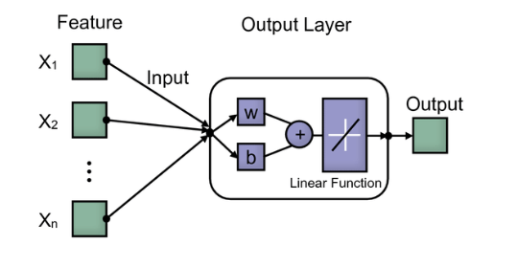

The architecture of a linear regression model is quite simple compared to more complex models. Here's a basic overview:

1. Input Layer: In linear regression, each input feature corresponds to a dimension in the input space. There is one input node for each feature in your dataset.
2. Output Layer: Linear regression predicts a continuous value, so there is only one output node in the output layer.
3. Weights: Each input node is connected to the output node through a weight. These weights represent the coefficients of the linear equation. There is one weight for each input feature, and an additional bias term (intercept) is also included.
4. Activation Function: Unlike in other models like neural networks, there is no activation function applied to the output of the linear regression model. The output is simply the weighted sum of the input features plus the bias term.
5. Loss Function: Commonly used loss functions for linear regression include Mean Squared Error (MSE) or Mean Absolute Error (MAE), which measure the difference between the predicted values and the actual target values.
6. Optimization Algorithm: Gradient Descent or its variants are commonly used to optimize the weights and bias of the linear regression model in order to minimize the chosen loss function.

**2.Random Forest**

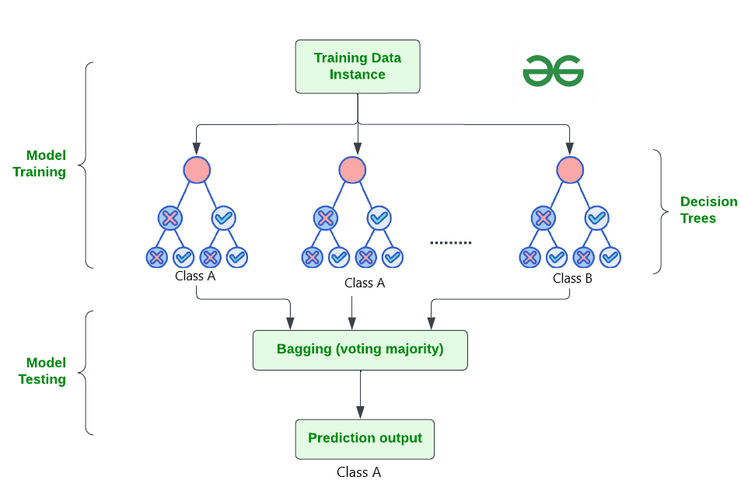

**The architecture of a Random Forest model is based on an ensemble of decision trees. Here's an overview of its architecture:**

1. **Decision Trees: The fundamental building blocks of a Random Forest model are decision trees. Each decision tree is constructed recursively by splitting the data based on the values of input features, aiming to maximize the purity of the resulting subsets (e.g., Gini impurity or information gain).**
2. **Ensemble Learning: Random Forest operates by building multiple decision trees, each trained on a random subset of the training data and using a random subset of the features. This randomness helps to reduce overfitting and improves the generalization ability of the model.**
3. **Bootstrap Aggregating (Bagging): Random Forest uses a technique called bagging, which involves training each decision tree on a bootstrap sample (randomly sampled with replacement) from the original dataset. This helps to introduce diversity among the trees in the ensemble.**
4. **Random Feature Selection: At each split in the decision tree, only a random subset of features is considered for splitting. This further diversifies the trees and prevents individual trees from dominating the ensemble.**
5. **Voting or Averaging: For regression tasks, the predictions from individual trees are typically averaged to produce the final prediction. For classification tasks, the predictions from each tree are often aggregated through voting (either by simple majority or weighted voting).**
6. **Hyperparameters: Random Forest has several hyperparameters that control its behavior, such as the number of trees in the forest, the maximum depth of the trees, the minimum number of samples required to split a node, and the maximum number of features to consider at each split.**

For Hyperparameter tuning:

Grid Search:

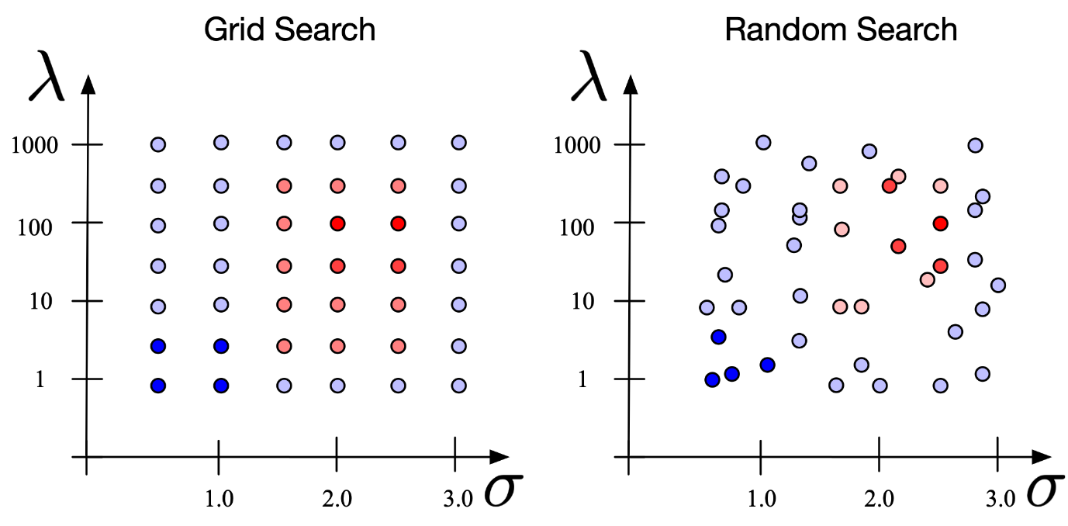

Grid search is not a machine learning model itself, but rather a technique used for hyperparameter tuning in machine learning models. It systematically searches through a specified grid of hyperparameters to determine the optimal combination that yields the best performance for the given dataset.

This is how grid search works within the context of machine learning models:

1. **Define Hyperparameter Grid:** Specify a grid of hyperparameters and their respective values that you want to explore. For example, if you're training a support vector machine (SVM) classifier, you might specify different values for the C parameter and the kernel type.
2. **Cross-Validation:** Split your dataset into training and validation sets. During grid search, perform k-fold cross-validation on the training set, where the dataset is divided into k subsets (folds). Each hyperparameter combination is evaluated using cross-validation to estimate its performance.
3. **Model Training and Evaluation:** For each combination of hyperparameters in the grid, train a new model using the training data and evaluate its performance using the validation data. The performance metric used can vary depending on the specific task (e.g., accuracy for classification, mean squared error for regression).
4. **Select Optimal Hyperparameters:** After evaluating all combinations, select the hyperparameter combination that yields the best performance based on the chosen evaluation metric. This combination represents the optimal set of hyperparameters for your model.
5. **Model Training on Full Dataset:** Optionally, once the optimal hyperparameters are identified, you can retrain the model on the entire dataset using these hyperparameters to maximize performance before deploying it for inference on unseen data.

**DATASET DETAIL:**

1. **Dataset Description**: The dataset contains sales figures for various food and non-food items across multiple months, ranging from April to March (presumably covering a one-year period). The products include dry fruits, snacks, cosmetics, household items, and other consumer goods.
2. **Data Attributes**:
   * Item Details: Contains the product names or codes.
   * Apr to Mar: Columns representing the sales figures for each month, from April to March.
3. **Data Dimensionality**: The dataset consists of many rows , each for a specific item, and 13 features (columns), including the Item Details column and 12 columns for monthly sales figures.
4. **Data Source**: The data is a real-time dataset from a super stockist. The file represents the sale of each item the super stockist firm has done .
5. **Time Period**: The dataset covers sales data from April to March, potentially spanning a one-year period.
6. **Data Scale**: The dataset contains sales figures for many distinct products across 12 months, which can be considered a moderate-sized dataset.
7. **Data Challenges**: Potential challenges or limitations of the dataset include:
   * Missing values: Some cells in the dataset appear to be empty, indicating missing sales figures for specific products in certain months.
   * Varying units or scales: The sales figures may be recorded in different units or scales for different products, which could require normalization or scaling.

**RESULTS**:

Comparing the accuracy for Linear Regression and Random Forest Model



Accuracy for Grid Search Model for each month (Apr-Mar)

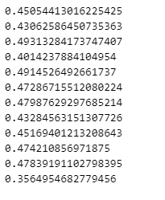

Prediction for the April 2025 sale for the first 30 items

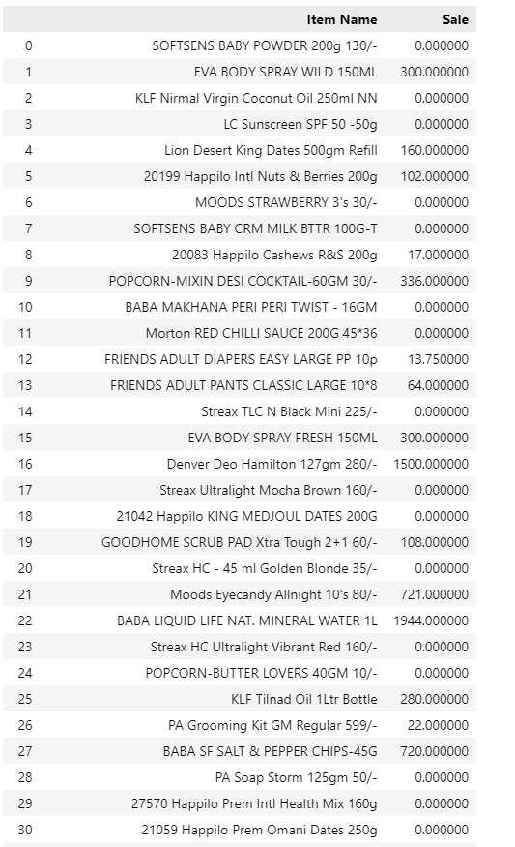

**CONCLUSION**:

An intelligent sales prediction system is imperative for modern business organizations grappling with vast volumes of data. The efficacy of business decisions hinges upon the swiftness and precision of data processing techniques. In this research paper, we advocate that machine learning methodologies offer an effective means to fine-tune data and enhance decision-making processes. To stay competitive in the dynamic business landscape, organizations must adopt contemporary approaches capable of accommodating diverse customer behaviors while accurately forecasting lucrative sales turnovers.

Our study leveraged a substantial dataset comprising nearly 85,000 records for algorithm comparison. However, due to the substantial time required for execution and the complexity of managing such extensive datasets, a portion of the records had to be discarded during the analysis phase. Concurrently, we encountered a significant challenge concerning the inadequacy of fields and attributes utilized in the analysis, hindering further exploration. This obstacle posed a considerable hurdle throughout our research endeavors.

Addressing these complexities demands not only innovative methodologies but also a keen understanding of the intricate interplay between data, algorithms, and business objectives. By delving deeper into these challenges, we aim to illuminate potential solutions and pave the way for more effective and efficient sales prediction systems in the realm of modern business.

**REFERENCES:**

* <https://www.researchgate.net/publication/372534840_Sales_forecasting_using_machine_learning_algorithms>
* <https://www.researchgate.net/publication/375238697_An_Analysis_of_Time_Series_Analysis_and_Forecasting_Techniques>
* [<https://www.irjmets.com/uploadedfiles/paper/issue_3_march_2023/34569/final/fin_irjmets1679321607.pdf>](https://www.irjmets.com/uploadedfiles/paper/issue_3_march_2023/34569/final/fin_irjmets1679321607.pdf)
* <https://www.researchgate.net/publication/372335607_Forecasting_of_a_Fashion_Retailer's_Sales_using_Machine_Learning_through_COVID-19>
* <https://www.researchgate.net/publication/356824621_Comparative_Analysis_of_Supervised_Machine_Learning_Techniques_for_Sales_Forecasting>
* <https://ieeexplore.ieee.org/document/8659115>
* <https://ieeexplore.ieee.org/document/8768765>
* <https://link.springer.com/article/10.1007/s00521-016-2215-x>
* <https://link.springer.com/article/10.1007/s10462-018-9637-z>